远程连接oracle 数据库，报无监听

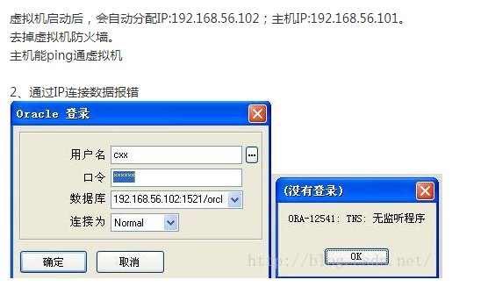

3、修改listener.ora

SID_LIST_LISTENER =

(SID_LIST =

(SID_DESC =

(GLOBAL_DBNAME = ORCL)

(SID_NAME = ORCL)

(ORACLE_HOME = C:\app\CXX\product\11.2.0\dbhome_1)

)

(SID_DESC =

(SID_NAME = CLRExtProc)

(ORACLE_HOME = C:\app\CXX\product\11.2.0\dbhome_1)

(PROGRAM = extproc)

(ENVS = "EXTPROC_DLLS=ONLY:C:\app\CXX\product\11.2.0\dbhome_1\bin\oraclr11.dll")

)

)

LISTENER =

(DESCRIPTION_LIST =

(DESCRIPTION =

(ADDRESS = (PROTOCOL = IPC)(KEY = EXTPROC1521))

(ADDRESS = (PROTOCOL = TCP)(HOST = localhost)(PORT = 1521))

(ADDRESS = (PROTOCOL = TCP)(HOST = 192.168.56.102)(PORT = 1521))

)

)

